(Section 1 of 5)

What Students Will Learn to Do:
This chapter will introduce you to the Navy Junior Reserve Officers Training Corps—its background, mission, curriculum, and activities, as well as its benefits to cadets.

Skills and Knowledge to be Gained:
  - Explain the history and background of the NJROTC
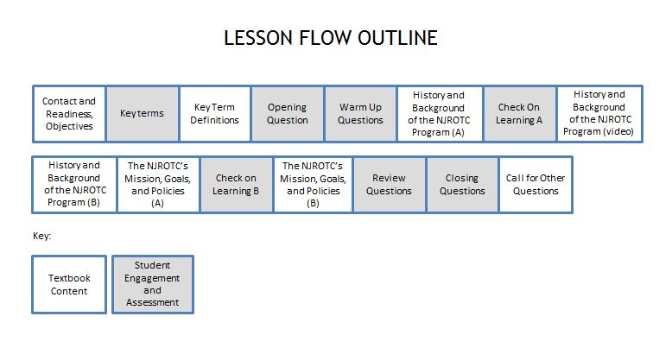
  - Describe the NJROTC’s mission, goals, and policies

Outline of Instruction:
- Preparation
            - Log in to TPC.
            - Expand the folders in the Content Window until you see NS1, U1, C1, S1.
Highlight the PPT - NS1-U1C1S1 – Intro to NJROTC
Click on PowerPoint Polling to open PPT and start slide show

            - Ensure that every student has a functional response pad and a textbook.

II. Instructional Flow:
Flow Item | Textbook Content / Student Engagement and Assessment | Slides
Establish contact and readiness; provide lesson overview and objectives review | Motivate students by relating real or imaginary events to help them see what the lesson will involve. Explain how this lesson ties in with other lessons.  In this lesson, students will learn about the NJROTC program. In addition they will:  1. Be able to state the program’s mission, goals, and policies.  2. Learn that the Navy Core Values- honor, courage, and commitment- are important parts of the NJROTC program, what they mean and how they are exemplified.  3. Learn what the Naval Science curriculum is all about  4. Learn the various activities in which NJROTC units participate.  5. Learn the benefits of belonging to the NJROTC | 1-3
Key term questions Slide index | Index Slide allows you to jump to any key term polling question. Clicking on the house icon at the bottom of any of the key term slides will bring you back to this index slide. | 4
Team Assignment (Hidden) | This is a hidden slide for gaming –It Is NOT required for the lesson | 5
Key terms – Questions | Ask students to respond to the questions covering each key term. | 6-14
Key terms - Definitions | Reinforce the correct definition for each key term. | 15-16
Opening Question(Randomly Selected Student – “RSS”) | This Opening Question is “List the 2-3 reasons you chose to enroll in JROTC.” Since this is a discussion question, it can be engaged using the “Randomly Selected Student” icon on PPT slide to select a clicker number randomly. That student will orally answer the question (not with his/her clicker). You might allow the students to discuss the question for 30-60 seconds with a partner before engaging the RSS question. The MobiView tablet can be used to write the students’ responses to the question on the slide, focusing on intro to the NJROTC. | 17
Warm-Up Questions(Lesson questions 1-2) | Warm-up questions are typically used to gauge students’ level of interest, to generate interest in learning about upcoming topics, or to gauge prior opinions, knowledge or confidence in their knowledge, and/or uncover misconceptions that might be present. There may or may not be correct answers to these questions.  Ask students to respond to each Warm-up question, with follow-up discussion based on responses as appropriate. | 18-19
History and Background of the NJROTC Program | Explain that you have chosen to take part in one of the most diverse and interesting programs in which a high school student can participate, joining more than half a million other students across the United States. The Junior Reserve Officers Training Corps, or JROTC, program currently enrolls students in more than 3,000 programs ranging from Alaska, Hawaii, and the continental United States to Japan, Italy, and Spain. | 20
History and Background of the NJROTC Program | Explain that the JROTC program was the brainchild of Army inspector Lt Edgar R. Stevens, who in 1911 began teaching high school students the values and discipline of a military life in the hopes of molding these students into better citizens. From this idea came the formation of the JROTC program with the signing of the National Defense Act of 1916 and the establishment of the first JROTC at Leavenworth High School in Kansas in 1917. After World Wars I and II, the JROTC program saw little to no growth because of limited funding and personnel. This lack of growth prompted Congress to pass the JROTC Vitalization Act of 1964, which allowed the other service branches to offer JROTC as well. | 21-23
History and Background of the NJROTC Program | Explain that the first Navy Junior Reserve Officers Training Corps (NJROTC) programs began in 1966. Today there are 620 NJROTC programs. The JROTC Vitalization Act charges the Secretary of the Navy with the maintenance and continued support of the NJROTC program. To this end, the Naval Service Training Command (NSTC), was established in Great Lakes, Illinois to manage funding as well as the personnel and materials the NJROTC program’s use. The Program Office is in Pensacola, Florida. Directly beneath NSTC are Area Managers, who control the NJROTC’s areas of operation and are responsible for maintaining the integrity of the programs in their areas through annual inspections. Beneath the Area Managers are Program Managers, or NJROTC instructors. | 24-27
History and Background of the NJROTC Program | Explain that NJROTC instructors must be certified by the Navy. They are retired Navy, Marine Corps and Coast Guard officers as well as enlisted personnel. Senior Naval Science Instructors (SNSI) are retired officers in charge of the individual programs, while Naval Science Instructors (NSI) are retired officers or senior petty officers who assist the SNSIs. The Naval Service Training Command certifies instructors on the basis of their active-duty records in positions of responsibility, meaning that most instructors have extensive experience in leadership and management positions. Some instructors also have experience as teachers and counselors. | 28
Check on Learning Questions A (Lesson Questions 3-4) | Check in on student’s understanding of information covered thus far by engaging lesson questions 3 and 4, with follow-up discussion as necessary. | 29-30
History and Background of the NJROTC Program | Show video on the History and Background of the NJROTC Program | 31
History and Background of the NJROTC Program | Explain that the Navy provides textbooks, computers, audio-visual equipment, and other materials for the Naval Science classroom, as well as uniforms for students to wear while they are in the program. Each unit also receives equipment for extracurricular activities like color guard, drill team, and marksmanship, as well as funding for orientation trips to military bases and other sites of importance to unit members. | 32-34
History and Background of the NJROTC Program | Explain that the NJROTC program is a joint effort of the U.S. Navy and local school systems to enhance the education of students who join. But the instructors work for the principals of their schools, just as any other teacher does. Local educators are responsible for administering the NJROTC program at their schools and for assisting the program as needed. | 35
The NJROTC’s Mission Goals, and Policies | Explain that the JROTC program’s mission is stated in the National Defense Act of 1916: The purpose of JROTC is “to instill in students the value of citizenship, service to the United States, personal responsibility, and a sense of accomplishment.” | 36
Check on Learning Questions B (Lesson Questions 5-6) | Check in on student’s understanding of information covered so far by engaging lesson questions 5 and 6, with follow-up discussion as appropriate. | 37-38
The NJROTC’s Mission Goals, and Policies | Explain that, to this end, the NSTC has established specific goals for the NJROTC program. These goals are as follows:  • Promote patriotism. This means love of country, respect for the flag, and pride in the government and the American way of life.  • Develop informed and responsible citizens. NJROTC should make students aware of their responsibilities, duties, and rights.  • Promote habits of orderliness and precision. Experience shows that such habits help people succeed in life.  • Develop a high degree of personal honor, self-reliance, self-discipline, and leadership. These qualities are embodied by the Navy’s Core Values of Honor, Courage, and Commitment.  • Promote an understanding of the basic elements and requirements for national security. Students should understand the need for armed forces and their relationship to a democratic government.  • Develop respect for and an understanding of the need for constituted authority in a democratic society. Students should understand why we have laws and governments.  • Provide incentives to live healthy and drug-free lives. Students should know how drug use and other harmful actions affect both themselves and others.  • Develop leadership potential. The NJROTC program provides students with a wide range of opportunities to test themselves in leadership roles such as leading a drill team and performing a staff job.  • Promote high school completion. Students should know the value of their education.  • Provide information on the military services as a possible career. | 39-43
Review Question-(Randomly Selected Student – “RSS”) | The Review Question is, “What was the most important thing you learned in this lesson that you didn’t already know? Why was it important to you?” This question is designed to provide an opportunity for some reflection and assimilation of the content covered and is to be engaged in with the “Randomly Selected Student” icon as the Opening Question above. MobiView can be used here to write the students’ best responses for visual reinforcement, and to foster discussion. | 44
Closing Questions (Lesson Questions 7 - 8) | Have students respond to questions 7 and 8 covering the final segment of the lesson, with follow-up reinforcement and discussion as appropriate. | 45-46
Call for Other Questions | Provide the opportunity for students to ask final questions regarding the content covered. | 47

III. Supplemental Activities -
A. In Class Activity 1:
Supplies Required: Multiple (6-8) soft throwables (nerf balls, fleece balls, koosh balls, bean bags, stuffed toys) for each group
When: Can open or close a class
- This activity requires breaking the class into groups of 8-12. Good for bonding and introducing students to each other and identifying potential leaders. 20-30 minutes. During this activity, look for who is taking charge. Are they listening to everyone, leaders standing out?
Group Juggling:
- Form groups into circle.
- Can only have one object in their hand at one time.
- Cannot drop any balls
- Give 1 throwable to someone in the group, “The Starter”. They must throw the object to someone who has not caught the ball.
  - The person must not be directly next to them. They must call the person they are throwing it to by name (If you do not know the name, ask the person their name, then say their name and throw them the object.
  - The person catching the ball follows the same procedure in throwing the ball to the next person.
  - When everyone has caught the ball, the ball is thrown back to the person who threw it first. This person calls the person they originally threw it to by name and throws the object to them. The pattern is repeated so everyone knows the pattern.
  - When the object gets back to the start, facilitator asks if anyone can name everyone in the circle. Allow people in the circle to try.
  - Have the start person start the ball again (same pattern). Insert a second, a third …ball into the system. They must call the name of the person they are throwing to; each time they throw it.
  - Stop the cycle. Ask them what happened? How many objects can they handle at one time? Give them 1 minute to discuss strategy. Try it.
  - Ask people to name everyone in the circle. Reflect on how they did? Did they improve? What caused improvement? Did you communicate?

B. Homework Activity: Have the students fill out the crossword puzzle handout with the key terms from the lesson.

Solution:
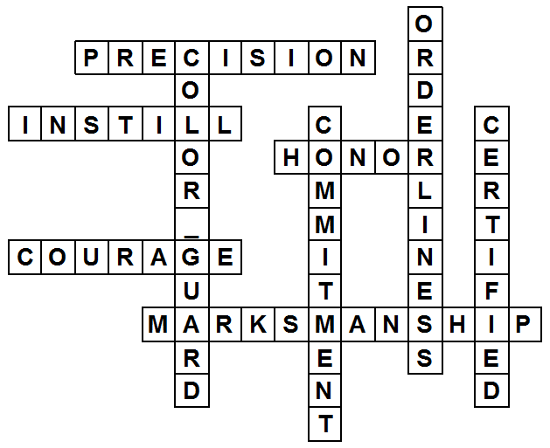

IV. Evaluation - see TPC Content Window (U1C1-Assessments folder) for chapter test questions.

Activity 1: Take Home Activity – Crossword Puzzle
Name: _______________________________ Date: ___________ Class: ___________
Directions: Fill the blank crossword puzzle with key terms from this lesson using the clues below. The answer to one clue consists of two words with a space.
